How to Install Eclipse APACHE TOMCAT (Runtime environment)

You need to go to **Help>Eclipse Marketplace** .

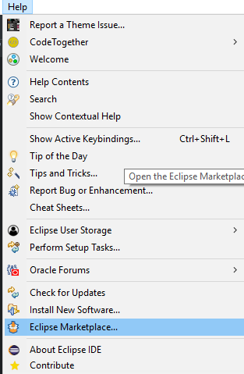

Then type server in the search box it will display **Eclipse JST Server Adapters** (Apache Tomcat,...) .Select that one and install it .

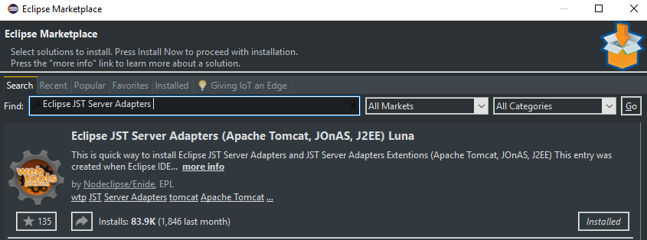

Then go back to **Window>Preferences>Server>Runtime Environnement**,

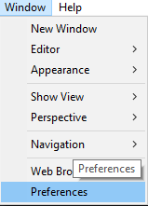

click add choose Apache tomcat version then add the installation directory .

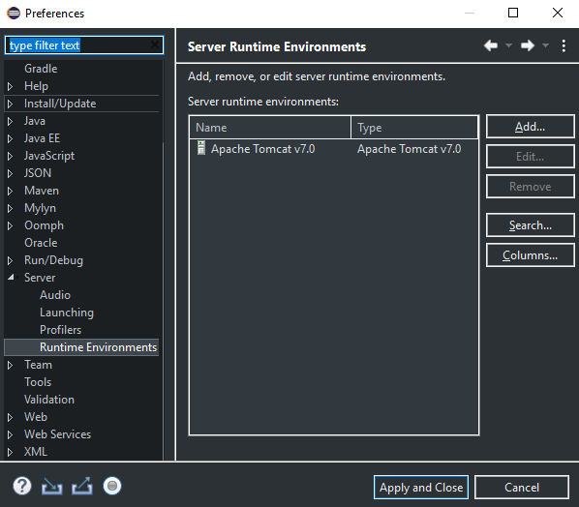

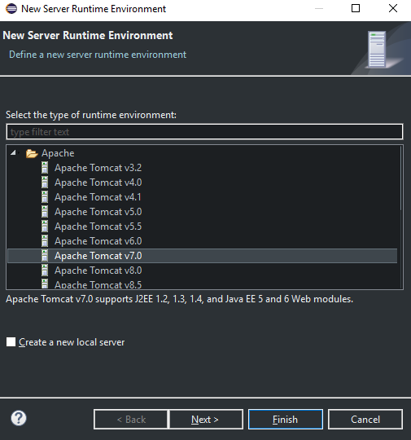

Click finish.

After this point you must have Tomcat available to run Web Applications in Eclipe.